INSTRUCTION TO AUTHORS

Manuscripts should be written in MS Word (Windows) and sent as a xxx.doc or xxx.docx file and pdf file for checking the correctness and completeness of the electronic record.

Manuscripts should be written in Croatian or English. Every paper in Croatian at its end should contain:
1. The title in English
2. Affiliations of authors and co-authors in English
3. Abstract in English
4. Key words in English

MANUSCRIPT LENGTH AND MARGINS
Manuscripts should contain no more than 6 (six) pages, including figures, tables and references. Pages should not be numbered.
The manuscripts must not contain explicit commercial advertisements.
The recommended margins are 25 mm.

FONT TYPE AND SIZE AND SPACES BETWEEN LINES
Use a 12 pt Times New Roman font, with single space spacing. As shown in the example, it is necessary to leave an empty line before the title, subtitle and names of figures and tables, as well as before and after the equations. An empty line should be inserted between sections of text as well. Do not leave an empty line between references.

MATHEMATICAL SYMBOLS AND EQUATIONS
It is best to use the Equation Editor in MS Word. In equations, as well as in text, use italics to write symbols that represent variables and parameters, including super and subscripts. Use only the symbols available in the Equation Editor, in the Symbol font, or in Times New Roman.

MEASURES AND UNITS
Authors are encouraged to use the SI metric system of units of measurements. In cases where other types of units may serve to enable a better understanding of the text, they can be added in parentheses immediately next to the SI unit. For help in using the SI system please consult: http://physics.nist.gov/cuu/Units/index.html.

SUBMISSION OF MANUSCRIPTS

Manuscripts are sent as attachments to:

radovi-zrak2021@huzz.hr in the following form: surname_name_paper_X.doc

(X marks the number of the contribution if the first author is sending more than one paper)

In case the electronic record cannot be sent by e-mail due to its size, it can also be sent via a link with prior notice to the above e-mail address.

Name and surname¹, Name and surname², Name and surname³ (Times New Roman, 12 pt, bold)
[Empty line]
TITLE (Bold 14 pt, Times New Roman, CAPITAL LETTERS, centered)
[Empty line]
Abstract: The abstract should contain no more than 200 words, the aims of the work, a description of the materials and methods used, results, and conclusions. (Times New Roman font, 12 pt, italic, single space)
[Empty line]
Keywords: Choose up to five words and/or phrases (of up to three words) describing the work (Times New Roman font, 12 pt, italic)
[Empty line]
INTRODUCTION
(Times New Roman, 12 pt, single space)
[Empty line]
MATERIALS AND METHODS
(Times New Roman, 12 pt, single space)
[Empty line]
RESULTS
(Times New Roman, 12 pt, single space)
[Empty line]
The results can be presented as text, in tables or in figures. The same results must not be presented in two or more ways.
[Empty line]
Example of a table:
[Empty line before table]
Table 2. Prevalence of respiratory symptoms (font in the table should be the same as it the text, i.e. Times New Roman)
Symptoms | Exposed | Control | Overall
Coughing | 70 | 65 | 135
Irritation of nose or throat | 80 | 89 | 169
Overall | 150 | 154 | 304

[Empty line after table]

Example of a figure:

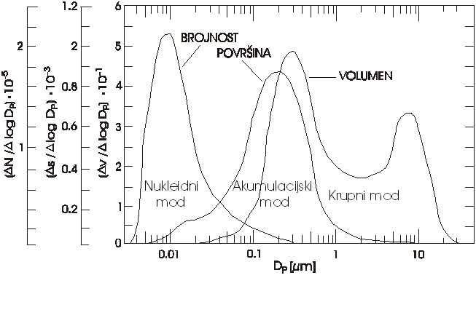
Figure 1. Number, surface and mass concentration of suspended particles (font in the figure should be the same as it the text, i.e. Times New Roman)
[Empty line after figure]

Example of equation:

Equations should be numbered at the right margin:

(1)

Symbols should be defined when first mentioned in the manuscript.

DISCUSSION
[Empty line]
(Times New Roman, 12 pt, single space)
[Empty line]
CONCLUSIONS
[Empty line]
(Times New Roman, 12 pt, single space)
[Empty line]
ACKNOWLEDGEMENT
[Empty line]
(Times New Roman, 12 pt, single space)
[Empty line]
REFERENCES
[Empty line]
Do not use empty line between references. Use hanging indent of 0.75 cm instead, as shown in the example.

Examples for references:

Manuscript in a journal:
Ravindra K, Sokhi R, Grieken RV. 2008. Atmospheric polycyclic aromatic hydrocarbons: source attribution, emission factors and regulation. Atmospheric Environment 42: 2895–2921. https://doi.org/10.1016/j.atmosenv.2007.12.010.

Conference paper in the Book of papers (proceedings):
Bešlić I. 2005. Lebdeće čestice u atmosferi grada Zagreba. U: Zbornik radova Četvrtog hrvatskog znanstveno-stručnog skupa “Zaštita zraka ‘05”, Šega K (ur.), 12-16. rujna 2005., Zadar, Hrvatska, str. 15-26.
Vadjic V. 2003. Air quality in Croatia monitoring and categorization at regional scale. Proceedings of the 14th International Conference “Air Quality – Assessment and Policy at Local, Regional and Global Scales”, Šega K (ed.), 6.-10. listopada 2003., Dubrovnik, Hrvatska, str. 783-792.

Book or chapter in a book:
Sexton K, Ryan PB. 1988. Assessment of human exposure to air pollution: Methods, measurements and models. In Air Pollution, the Automobile and Public Health, Watson AY, Bates RR, Kennedy D, eds., Washington DC: National Academy Press, pp. 123-135
WHO (World Health Organization). 1987. Air Quality Guidelines for Europe; WHO: Copenhagen, Denmark.

Source from Internet:
WHO (World Health Organization). 2016. Global Urban Ambient Air Pollution Database, Geneva, Switzerland. https://www.who.int/airpollution/data/cities-2016/en/ (29.4.2021.).

